Please complete in BLOCK CAPITALS 2023
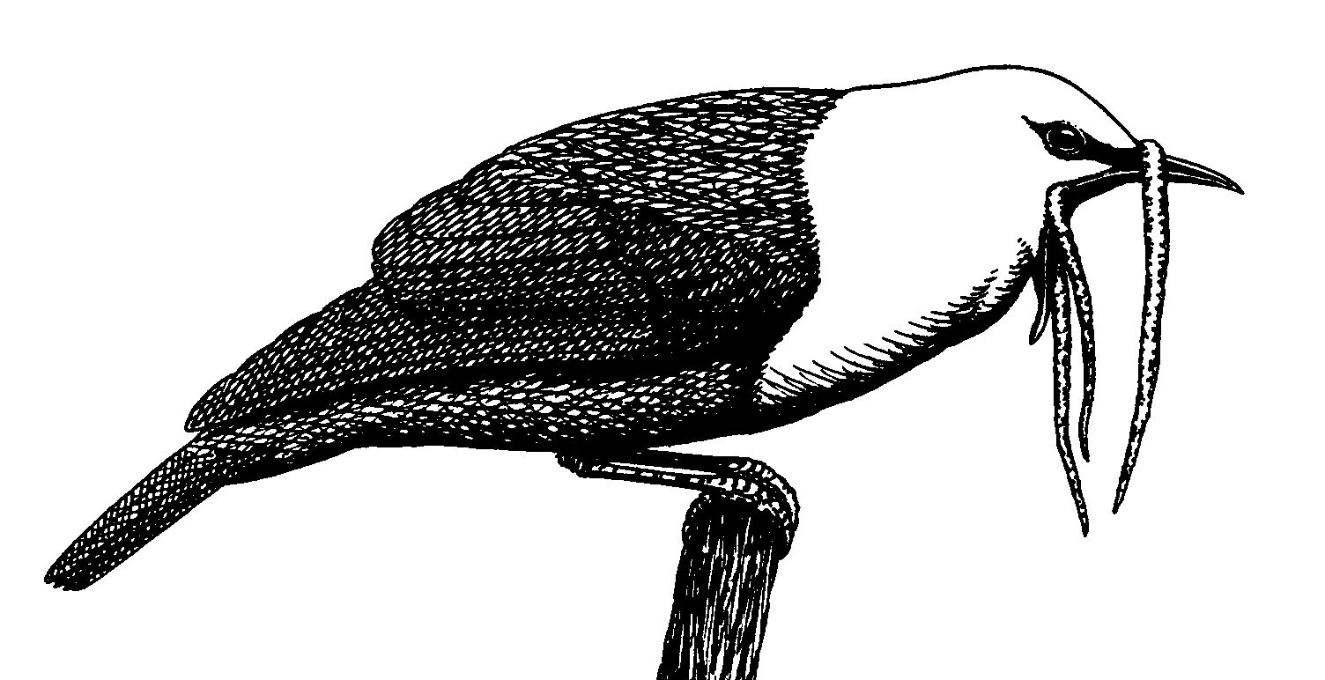Neotropical Birding and Conservation
c/o The Lodge, Sandy, Bedfordshire SG19 2DL
Registered Charity Number: 1196505

Dear Member,
I am enclosing this form with your journals to remind you that 2023 subscriptions are due on 1st January 2023. If you pay by standing “SO” on your address label, in which case your membership is up-to-date. Please note that you have the option to receive our publications online in digital format (pdf) instead of, or as well as, in printed form (see overleaf for details).
Prompt payment of subscriptions is much appreciated. Each year delays in payment of subscriptions cause us operational difficulties and cost the NBC money.
I hope you will renew your subscription and continue to support the NBC and Neotropical conservation. I encourage you to renew via our website as this is the most cost-effective method for the NBC, or you can use the attached form. Contact me for details of our Direct Debit payment option.
Supporting Membership - Due to the low number of members being suggested for “Sponsored Membership” we have changed the category to “Supporting Member”. Whilst members can still use “Supporting Membership” to sponsor a “Neotropical National Member” of their choice, if the member does not nominate a recipient, the NBC will try to find a suitable person to support. Should this prove impossible part of the payment will taken as an unrestricted donation to the NBC.
Please note that the RNN is a concessionary rate intended only for those in the region who cannot afford to pay the full rate. Those who can afford to pay the full rate are asked to do so. Members paying the RNN rate will only receive NBC journals in digital format.
Please provide your e-mail address. It is the most cost-effective way to communicate with you. Also, if you wish to be kept in touch with certain NBC developments please visit the website and follow the instructions on the “Keeping in Touch” link.
In returning this form you will disclose personal data to us (e.g. your name). Please see the Privacy & Cookies Notice on our website for information on how we use your data. If you want a hard copy of the Notice please email or write to the NBC address.
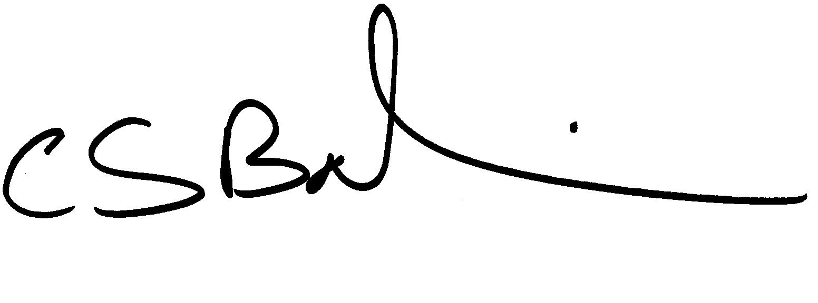
Yours sincerely,
Chris Balchin (Secretary)
E-mail: membership@neotropicalbirdingandconservation.org
Website: www.neotropicalbirdingandconservation.org

Name___________________________________________________________________

Membership number (if known) ____________________________________________

Address_________________________________________________________________

________________________________________________________________________

________________________________________________________________________

Preferred e-mail address___________________________________________________

Please tick type of membership required below:

Ordinary Member (journals in printed form) £26/$48/€39 digital only £24/$34/€30
Family Membership (printed form) £32/$60/€49 digital only £30/$42/€36
*Supporting Member (printed form) £45/$80/€65 digital only £43/$60/€52
Resident Neotropical Nationals (RNN) $25 (digital only)
Libraries & Academic Institutions £55/$100
*Sponsored Member no longer available - see over

Members wishing to receive our publications in digital form as well as in printed form
should add £5 (UK), €6 (Europe) or $7 (Rest of the world) to the applicable printed
membership rate. Members must be over 18 years old.

Membership £/$/€____________

Donation £/$/€ ____________

Total £/$/€ ____________

Method of payment (please tick) - currency must be as per your region
Cheque (UK£ or US$ only) payable to ‘Neotropical Birding and Conservation’ £/$ ____
Please charge my VISA or Mastercard £/$/€ ______

Card no. _____________________________________________

Security code (last 3 digits on back of card) _______ Expiry date ______________
Signature __________________________ Date _____________ 2023

