**NBC Global Birdfairdaily Bird Identification quiz.**

**Answers**

**Friday**

1. Araripe Manakin 2.Booted Rackettail 3. Great Antshrike

1. Lear’s Macaw 5.Double-striped Thicknee 6. Common Tody-Flycatcher

7.Blue-napedChlorophonia 8.Masked Tityra 9.Lyre-tailed Nightjar

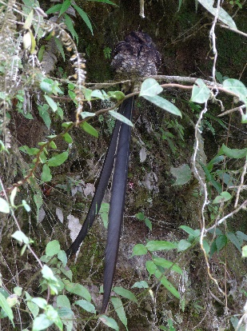

10. Black-headed Parrot

**Saturday**

1. Bee Hummingbird 2. Torrent Duck 3. Swallow-tailed Kite

**

4. Reddish Egret 5. Vermilion Cardinal 6. Cuban Tody

7. Black Curassow 8. Red and Green Macaw 9.

10. Blue-backed Manakin

**Sunday**

1. Red-necked Tanager 2. Sungrebe 3. Lanceolated Monklet

4.Lear’s Macaw 5. Sparkling Violetear 6. Saffron Finch

7. Blue-napedChlorophonia 8. Red-cowled Cardinal 9. Resplendent Quetzal

10. Cuban Trogon

