Please complete in BLOCK CAPITALS
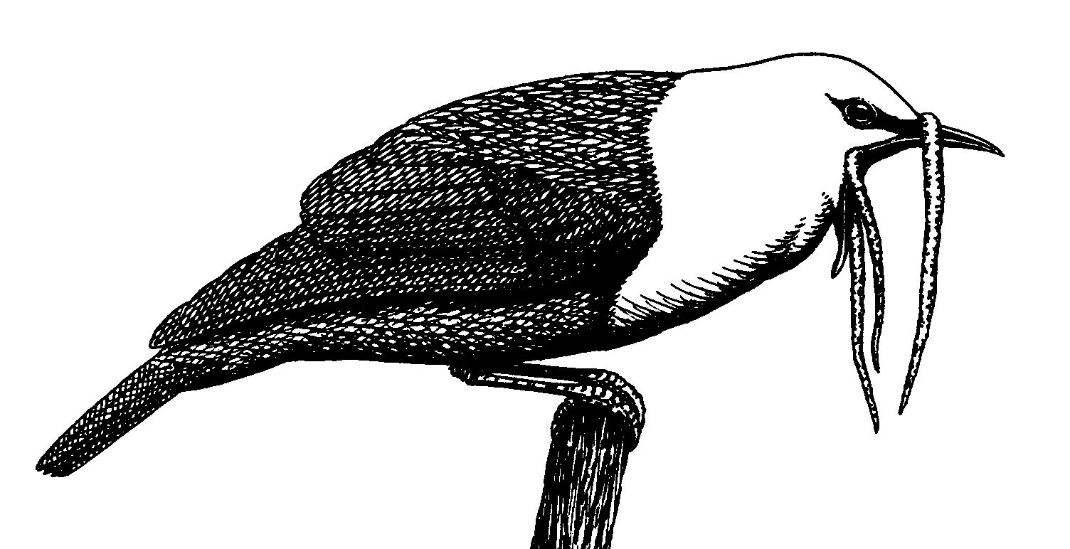 The Neotropical Bird Club 
c/o The Lodge, Sandy, Bedfordshire SG19 2DL
Registered Charity Number: 1040130

If you wish to join the Neotropical Bird Club by sending us a cheque or credit card details please fill in this form and post it to our registered address (or to our US mailing address). I encourage you to join via our website www.neotropicalbirdclub.org as this is the most cost-effective method for the Club. No surcharges are imposed for renewing with your credit card via our website.
Please note that the Resident Neotropical National rate is a concessionary rate intended only for those in the region who cannot afford to pay the full rate. Those who can afford to pay the full rate are asked to do so. Members paying the reduced rate will receive their NBC publications in one package when the second Neotropical Birding for the year is published. If you intend to renew as a sponsoring member please provide details of the person that you wish to sponsor otherwise the choice will be at the club’s discretion.
US and Canadian members can renew via our Cape May mailing address detailed below.
Please provide your e-mail address as this will help the club to communicate with you in the most cost effective way.

Yours Sincerely
Gordon Ellis
(Secretary)

E-mail membership@neotropicalbirdclub.org
Home Page http://www.neotropicalbirdclub.org
US and Canada mailing address-
PO Box 55, Cape May Point, NJ 08212-0055, USA.

Name ______________________________________________________________

Membership number (if known) ________________________________________

Address ____________________________________________________________

____________________________________________________________________

____________________________________________________________________

E-mail address------------------------------------------------------------------------------------
Please tick type of membership required below:
Ordinary Member UK based £26 ____
Ordinary Member (overseas)US$48/EU39 ___
Libraries & Academic Institutions UK£55 / US$100/EU81 ___
Resident Neotropical Nationals US$35 ___
Sponsoring Member UK£45 / US$80/EU65 ___
Family Membership UK£32 / US$60/EU49 ___
Two-year Ordinary Membership UK£52 / US$96/EU78 ___
Five-year Ordinary Membership UK£130 / US$240/EU195 ___
Life Membership UK£750/ US$1400/EU 1140 ___

Membership £/$ ____________

Donation £/$ ____________

Total £/$ ____________
Method of payment (please tick)
Cheque made payable to ‘Neotropical Bird Club’ ___
Please charge my VISA ___
MasterCard ___
Please note there is a 2% surcharge on credit card payments not made by our website
THERE IS NO SURCHARGE FOR CREDIT CARD RENEWAL VIA OUR WEBSITE

Card no. _____________________________________________

Security Code (last 3 digits on back of card) _______ Expiry Date ______________

Signature __________________________ Date _____________ 2015

