COLOMBIA LOST & FOUND
Main tour: 7 to 23 January 2019 (Bogota to Bogota)
Post-tour extension: 24 to 29 January 2019 (Bogota to Bogota)
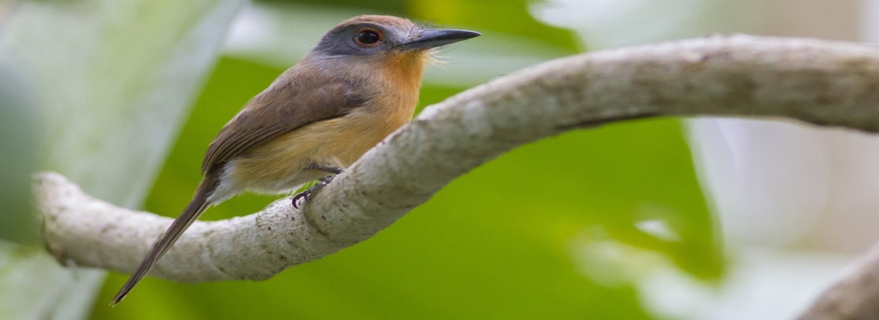
To be led by Forrest Rowland of Rockjumper Birding Tours
Grey-cheeked Nunlet by George L. Armistead

Colombia is undeniably the most biodiverse country on the planet. With three mountain ranges, two coastlines, high Andes and the Amazon Basin, opportunities for discovery and appreciation are endless. Unfortunately, this fabulous country was lost to ornithology and birders for decades amidst the strife for which the country became so well-known. But times have changed. Starting in the mid-2000s, exploration into the myriad of habitats and ecotones contained within the political boundaries of Colombia resumed in earnest. Infrastructure improved. Economy boomed. The government finally became aware of, and began to promote, the wild riches of their land. Nowadays, Colombia embodies a vision of wildly fulfilling adventures, staggering diversity of species, and the opportunity for discovery and contribution to ornithological knowledge for birders around the globe. It has become the new frontier.
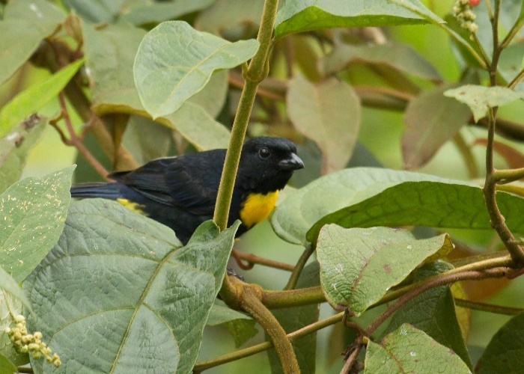
Specifically designed for the Neotropical Bird Club & focusing on seldom-visited or recently-discovered sites and species, Colombia – Lost and Found will take participants across several distinct regions of Colombia, and through an impressive array of eco-habitats, in search of some of the World's rarest and most sought-after bird species. Join us for a truly unique experience in the wild lands of Colombia for some of the most exciting birding imaginable, and an enjoyable immersion into the best that this fantastic country has to offer.
Golden-chested Tanager by Dušan Brinkhuizen

The tour begins around Bogota, high in the Eastern Andes, to search for such iconic species as Green-bearded Helmetcrest, Bronze-tailed Thornbill, Bogota Rail and Apolinar’s Wren. More targets will include Golden-bellied and Blue-throated Starfrontlet and Rufous-browed Conebill.
With three days to explore the vicinity of Valledupar, Manaure and the high Perija mountains, we will explore a broad diversity of habitats. Ranging from dry forests, subtropical cloud forests and into paramo, where most of the Perija endemics are found. More than 300 species are possible in just a few days! Highlights might include Crested Quetzal, Lance-tailed Manakin, Chestnut Piculet and White-whiskered Spinetail in the dry lowlands, then Perija Brush Finch in the foothills and Perija Tapaculo (yet to be fully described!), Perija Metaltail and Perija Thistletail in the highlands, plus interesting subspecies such as Perija (Rufous) Antpitta.
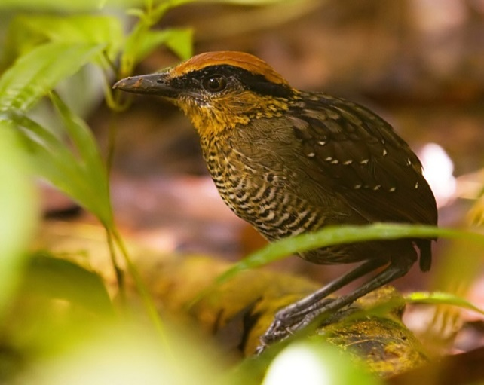
Until only the past two years, the Uraba region of Colombia received no acknowledgement as the fabulous birding destination that it is. Sooty-capped Puffbird, and Baudo Oropendola were known to be in the area prior to 2015. However, local guides and research have really brought to light the fact that the area is home to some incredible birds, such as, Rufous-crowned Gnatpitta, Black Oropendola, Grey-cheeked Nunlet and Viridian Dacnis!
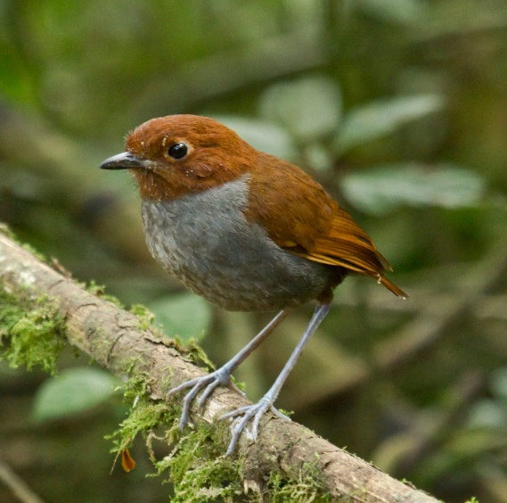
In the Central Andes we will search for Cauca Guan, Multicolored Tanager, Crested Ant-Tanager and many other subtropical specialties before heading into the temperate zone near the country’s tallest active volcanoes. There the critically endangered Fuertes’ (Indigo-capped) Parrot awaits us in the possible company of Grey-breasted Mountain-Toucan, Golden-plumed Parakeet, Black-thighed Puffleg and Bicolored Antpitta.
Bicolored Antpitta by Dušan Brinkhuizen
Rufous-crowned Gnatpitta by Dušan Brinkhuizen

Finally, we will conclude our exploration of Colombia’s birding frontiers in the Cali region. From marshes near the metropolis, where Horned Screamer and Apical Flycatchers reside, to the heart of the Chocó rainforests in search of Five-colored and Spot-crowned Barbets, Golden-chested Tanager and the outrageous Golden-collared Manakin, we will relish time in one of the largest intact tracts of Chocó cloud and foothill forests left on Earth.
An optional 6- day post-tour extension will visit Colombia’s bird rich Amazonian habitat around Mitu. Targets will include Brown-banded Puffbird, Bar-bellied Woodcreeper, Cherrie’s Antwren and more!
Price per person: Main tour: US$7,500 plus internal flights around US$495 & single room supplement US$495. Post-tour extension: US$2,450 extension plus internal fights around US$250 & single room supplement US$75. All prices Bogota to Bogota.
Booking: The tour is offered solely by Rockjumper Birding Tours. All bookings must be made through Rockjumper at https://www.rockjumperbirding.com/tours/colombia-lost-found-fundraising-tour-nbc or request a booking form via the email address below.
Further information & queries: for more essential information you should read before booking please see the attached pre-booking information document. For all queries please contact Rockjumper at private@rockjumperbirding.com (attention Cuan, Jeremy or Rynart).
COLOMBIA LOST & FOUND: MAIN TOUR & EXTENSION: PRE-BOOKING INFORMATION
Bookings and terms & conditions: The tour is offered and operated solely by Rockjumper Birding Tours (“Rockjumper”). Rockjumper’s terms and conditions apply. To make a booking please go to https://www.rockjumperbirding.com/tours/colombia-lost-found-fundraising-tour-nbc or request a booking form from private@rockjumperbirding.com (attention: Cuan, Jeremy or Rynart). Note a deposit of US$ 800 per person applies to the main tour plus US$500 per person for the extension.
Prices:
(A) Main tour price: US$7,500* per person (Bogota to Bogota) plus approximately US$495 per person for internal flights∞. Please see below for what is not included in the price.
Single supplement: US$495* per person for single room throughout the main tour.
(B) Extension tour price: US$2,450* per person (Bogota to Bogota) plus approximately US$250 per person for internal flights ∞. Please see below for what is not included in the price.
Single supplement: US$75* per person for single room throughout the post-tour extension.
Note unless otherwise stated what follows below applies to both the main tour and the extension.
*Price increase: The above prices were set 12 months in advance of the tour. Unfortunately, it is feasible that costs might increase. Thus, Rockjumper reserves the right to increase those prices to reflect any such increase. Please see Rockjumper’s terms & conditions for more detail.
∞ Internal flights: the above is an estimate of the flight costs. Should there be any difference in the final cost at time of ticketing, it will be adjusted on your final invoice.
The price of this tour includes: Accommodation as set out in the detailed itinerary available from Rockjumper (“the itinerary”); meals as set out in the itinerary (broadly speaking, on the main tour this is from dinner on day one to lunch on day 17, and on the extension, this is from breakfast on day one to breakfast on day six); transport as set out in the itinerary (but not international flights, transfers to or from Bogota international airport, or internal flights-see above for approximate cost of internal flights); the services of one Rockjumper leader and a local driver; local guides selected by Rockjumper; tips for local guides; reserve entrance fees; & bottled drinking water.
The price does not include: All items noted (above or below) as not included; any activities not included in the itinerary; international flights & any internal flights; laundry; travel or other insurance; additional nights due to flight delays or cancellations; excess weight charges on flights; any international departure tax; any passport and visa fees; any vaccination costs; tips & gratuities (other than as noted in the previous paragraph); drinks (other than bottled drinking water supplied by Rockjumper) ; telephone calls; all other items of a personal nature; all costs personally incurred by you either before, or in respect of the period before, the official start of the tour, or after, or in respect of the period after, the official end of the tour; and anything not covered in “the price of this tour includes”. Please see Rockjumper’s booking terms & conditions for more detail.
If you have any doubt about what is not included in the tour please ask Rockjumper before you book (please see contact email address below).
The (land package) price per person is based on double occupancy i.e. participants will have to share. Please see above for details on the single room supplement. The single room supplement only covers accommodation where single rooms are available.
Changes to itinerary: Please note that the itinerary may change due to local conditions such as weather or accommodation unavailability. Please see Rockjumper’s booking terms & conditions for more detail.
Arrival & departure details: The information given above and in the itinerary is a guide only. Precise arrival and departure information will be sent to you in your Tour Confirmation package once the tour has been confirmed as going.
International flights: No international flights are provided as part of this tour. You must arrange your own flights to fit with the itinerary. Please do not book any flights until you have an email from Rockjumper confirming there are sufficient participants for the tour to run (we need 6 participants to run the tour). For the start of the tour you must arrive in Bogota no later than 7 January 2019. Please check with Rockjumper your proposed departure time at the end of the main tour or, if relevant, post-tour extension. No international flights should be booked for 23 January 2019 because it is unlikely that the tour will be back in Bogota in time for such a flight. It is for this reason that accommodation will be provided for the night of 23 January. If you do book a flight for 23 January this will be at your risk and cost: the itinerary will not be shortened to accommodate anyone who does this. In terms of the end of the post-tour extension you should obtain written confirmation from Rockjumper that your proposed departure time is consistent with the proposed time of return from Mitu to Bogota. However, even this does not guarantee that you will make such a flight: you should bear in mind that delays & cancellations are a fact of life in Colombia and so it’s quite possible that you may not be back in Bogota on 29 January at all. Anyone booking an international flight from Bogota on 29 January (or later) does so at their own risk and cost.
Internal flights & cancellations: The itinerary details the internal flights. Rockjumper will book these for you. The cost will be added to your invoice. As noted cancellation of flights does happen in Colombia. If so, at best this may lead to minor changes to the itinerary, and, at worst, cancellation of parts of the itinerary (including potentially the whole of the post-tour extension to Mitu). Accordingly, you are strongly recommended to purchase cancellation insurance.
Your leader: Forrest Rowland is Rockjumper’s principal tour leader for Colombia. He has led groups of birders to the tropics for many years. You can find a biography of Forrest on the Rockjumper website. Please note Rockjumper reserves the right to change the leader at short or no notice due to unseen circumstances.
Group tour minimum & maximum: 6 participants are required for this tour to run. The maximum will be 8 (excluding the leader).
Passports, visas etc: You must check that you will be able to obtain the travel documents (including visas and vaccination certificates) required. Remember that you will probably have to have a full passport valid for at least six months after the end of the tour. These can take time to acquire, especially if this is a first passport.
Your national government or local Colombian embassy should be able to advise you on the travel documents you will need. For example, advice for UK citizens on entry requirements can be found at www.fco.gov.uk/knowledgebeforeyougo
Insurance: You are strongly advised to purchase adequate comprehensive travel insurance before leaving home. This should include cover to indemnify and protect you and your dependants against all costs and expenses of cancellation, curtailment, missed departure, delay (whether by reason of volcanic eruptions, volcanic ash or airline strikes or otherwise), loss of luggage passport and/or money, loss or damage to equipment you bring (e.g. camera, lenses and binoculars), personal accident (including vehicle accident), personal liability, illness, medical care, and repatriation should you become too ill to continue with the tour. For useful information on insurance see www.fco.gov.uk/knowledgebeforeyougo. If you need information about an insurance policy which covers the costs of cancellation, medical/injury assistance and repatriation please use the contact email address below.
Repatriation: Remember that this tour begins and ends in Bogota. Rockjumper is not responsible, & takes no responsibility, for your repatriation to your home (wherever that might be). As noted you should take out insurance to cover any repatriation costs.
Delayed arrival: It is your responsibility to get to Bogota in time for the tour’s designated start time. The tour cannot be delayed if you are late. If so, it will be your responsibility to meet up with the tour. As noted you should take out insurance to cover any associated costs.
Delayed departure: It is your responsibility to ensure that you have suitable travel arrangements in place for return to your home following the designated end of the tour. As previously noted, delays & cancellations happen in Colombia and so Rockjumper cannot guarantee you will be back in Bogota on 23 or (in the case of the extension) 29 January 2019 in time for an international flight on those dates or the following days. If your travel arrangements are delayed or cancelled it is your responsibility to secure alternative arrangements. As noted you should take out insurance to cover any associated costs.
Pre-payments: Note Rockjumper Tours are not ATOL bonded. However, Rockjumper is a member of SATSA which may provide reimbursement of pre-payments should an insolvency event happen. For more information please see:
https://www.rockjumper.com/2014/06/10/southern-african-tourism-services-association-satsa
Health & comfort: This tour is designed to visit remote and seldom birded locations. The style of birding is hardcore and fast. While this tour involves very little arduous walking, we will be at fairly high altitude on some occasions. You should be in good health and of good fitness to undertake this tour. If you have any physical limitations or medical conditions of any sort please do let the Rockjumper office know in advance booking the tour. Time will be spent in vehicles and walking birding sites. Some vehicle journeys will be many hours long and, as noted below, some roads could be bumpy: which some might find uncomfortable. There will be early morning starts & meal times will be irregular. We may have packed breakfasts & lunches in the field. Please contact Rockjumper (see below) if you are in any doubt about the required physical and mental fitness for this tour.
You need to check whether you have the vaccinations and medications you require for this tour. Please contact your medical practitioner for advice on what you require. Also, please remember that you should obtain well in advance of the tour’s departure the medication you require as some medication must be initiated weeks before the period of possible exposure. Neither Rockjumper nor its leader on the tour is able to provide or dispense medical advice or medication. Please note we will be birding in remote areas well away from modern medical facilities.
Helpful medical information can be found on government websites. For example, you might try the USA’s CDC Travel Health Website. More general health and other information can be found on the British Government’s foreign travel advice website http://www.gov.uk/foreign-travel-advice/colombia
Standard of accommodation & meals: the hotels we stay at are of reasonable standard throughout although on occasion they will be basic. Rockjumper will send you a list of hotels in due course with name, address & telephone and also a point of contact should you get in difficulty while in Colombia during the tour. Meals may not always be comparable with standards in more developed countries.
Standard of transport used: transport is by small coach or minibus and 4x4 vehicles where required, and the roads are mostly in good condition but (as previously noted) some can be bumpy & make for an uncomfortable ride. Further, due to the nature of the topography, there is the possibility of landslides interfering with our tour, though we hope to have minimised this risk by undertaking the tour during the drier season.
Weather: we expect the weather to be mostly dry and often sunny, and it can be hot and occasionally humid in the lowlands. At higher elevations visited, it can be quite cool, especially at night. There is likely to be some rain, which can be heavy.
Language: English is not widely spoken in Colombia. Forrest Rowland is fluent in Spanish.
Invoicing arrangements: final invoices will be issued 4 months prior to commencement of the tour.
Special requirements for you: If you have any special requirements (whether food or health related or otherwise) please check, prior to booking, with Rockjumper whether these can be accommodated (please see contact email address below).
Other information from Rockjumper: for further information including payments by you for currency fluctuations, single supplement terms, your final invoice for air ticketing, any refunds on cancellations (by you or Rockjumper), permitted tour alterations by Rockjumper, the standard of travel conditions, food & accommodation, the limit of Rockjumper’s responsibility to you (including its disclaimer), data privacy terms and Rockjumper’s complaints procedure please see Rockjumper’s booking terms & conditions. If you are in any doubt about what this means for you please check pre-booking through using the Rockjumper email contact address below.
Neotropical Bird Club (“NBC”): NBC is a UK registered charity run by volunteers to raise awareness of Neotropical birds and to promote their conservation. The information in this document is given in good faith. However, NBC does not guarantee the accuracy or completeness of its content. Further, NBC does not assume or accept any responsibility for its content or the contents of documents or websites referred to herein. Furthermore, as NBC is not selling, offering for sale, or handling bookings for, or undertaking the operation of, this tour NBC does not and cannot accept any liability in connection with or in relation to the booking or operation of this tour. Anyone booking for this tour or participating in it does so on the basis that he or she accepts NBC has no such responsibility or liability.
Email contact point for Rockjumper: private@rockjumperbirding.com (attention Cuan, Jeremy or Rynart). 21/02/2018

